1. Write a formula which can be dragged right and down to generate a multiplication table. (Generate Multiplication Table.xlsx)

**Solution:** 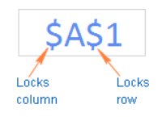 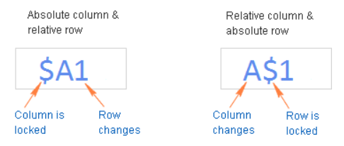

**Reference Link:** <https://www.ablebits.com/office-addins-blog/2015/11/25/relative-absolute-reference-excel/>